SPECIMEN
Thanksgiving Sunday at the Liturgy on (date)

[Theme / Feast / Fast if any]

[Title of the Sunday allocated:
eg., 2nd Sunday in Great Lent etc]

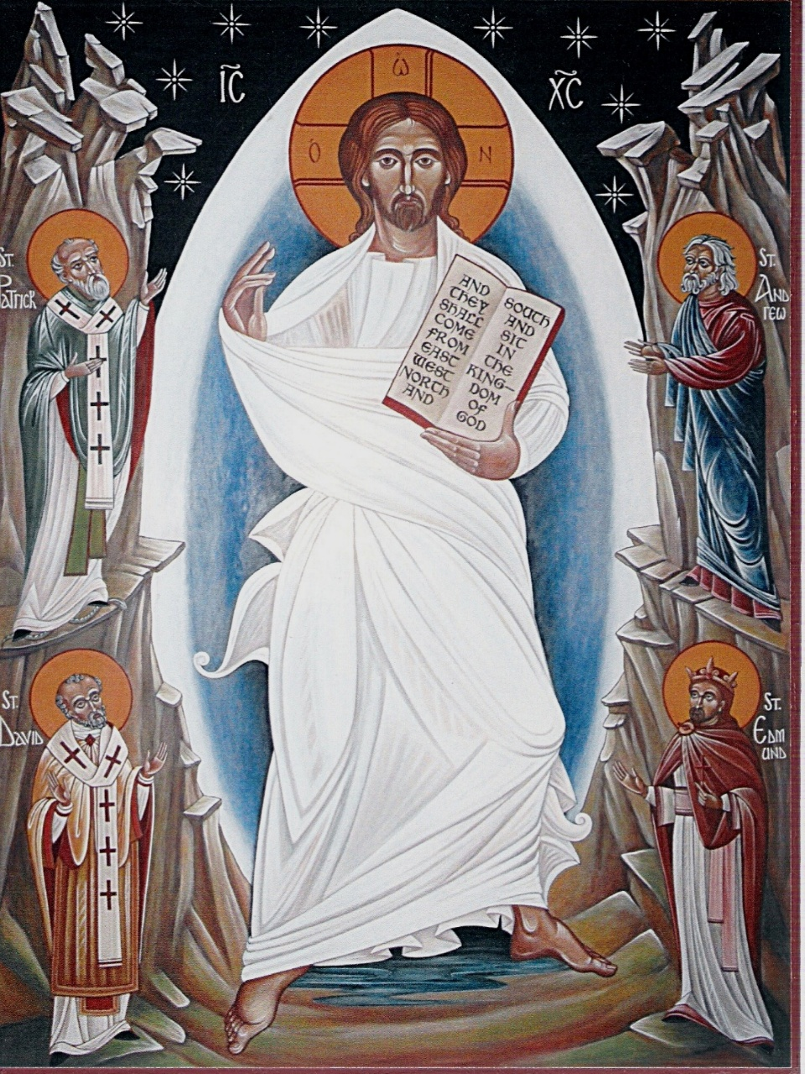
[or another appropriate graphic]

[Parish or Mission title]

THANKSGIVING SUNDAY LITURGY – [Date]

Christian giving is our responsibility as God’s stewards, both for the ministry of the Church and for the relief of the poor. We renew our giving every year to the Lord’s work in conformity with the teaching of the holy fathers, (especially Sts. John Chrysostom and John the Merciful), and the teaching of Scripture. Consider:-

THE GOSPEL "For you know the grace of our Lord Jesus Christ, that though he was rich, yet for your sake he became poor, so that by his poverty you might become rich."
[2 Corinthians 8:9]

THANKSGIVING "... for the rendering of this service not only supplies the wants of the saints but also overflows in many thanksgivings to God."
[2 Corinthians 9:12]

JOYFULLY "for God loves a cheerful giver ..."
[2 Corinthians 9:7]

WILLINGLY "... for they gave according to their means, as I can testify, and beyond their means, of their own free will."
SACRIFICIALLY [2 Corinthians 8:3]

GENEROUSLY "... he who sows sparingly will also reap sparingly, and he who sows bountifully will also reap bountifully."
[2 Corinthians 9:6]

TRUSTINGLY "... and God is able to provide you with every blessing in abundance, so that you may always have enough of everything and may provide in abundance for every good work."
[2 Corinthians 9:8]

REGULARLY "On the first day of every week, each of you is to put something aside and store it up as he may prosper ..."
that is:- PROPORTIONATELY – a part or percentage of your income.
[1 Corinthians 16:2]

[Name] Trust serves the parish / mission of [Name].

WHAT SHOULD I (OR WE, AS A FAMILY) DO NOW?

Please pray to the Lord for him to tell you what part of your income you should dedicate in thanksgiving to his work. Please do not think of an amount and then work backwards to the proportion! Pray about the part or percentage of your income you are going to give to God’s work over the next year.

The biblical guide to proportionate giving is of course the tithe or 10%, that is 10p in the £1. However, in Christ we live in grace, not by laws or rules. For some on low incomes this might be too much, (but, remember the widow’s offering at the Temple) For others it could be not enough. Please pray about it! There is not one standard that applies to all.

ONLY GOD CAN TELL YOU WHAT IS HIS WILL.
PLEASE DO NOT ASK THE CLERGY OR ANYONE ELSE WHAT TO GIVE.
DO NOT DISCUSS OR JUSTIFY YOUR DECISION WITH ANYONE EXCEPT GOD.
EXERCISE YOUR FAITH IN THE LORD WHO PROVIDES FOR ALL OUR NEEDS
SO, AFTER I'VE PRAYED .... WHAT NEXT?

On [DATE], (or beforehand if you are away this weekend), you will have an opportunity at the end of the Liturgy and in a moment of silence to complete your pledge card (provided). This action will confirm and offer in the Divine Liturgy what you will have already committed to the Lord in prayer at home. Unless you are away, this card will only be distributed at the Liturgy. It is essential that we commit prayerfully and together.

- Our preferred method for your giving is by BANK STANDING ORDER. Reliable income for the church should not depend on the reliability of our memories! If so moved, you can always give in addition to your bank standing order by cash or by card.
- IF YOU PAY INCOME TAX please use GIFT AID by ticking both boxes on the card.
- NON TAX PAYERS can give by cash in the collection basket or in the candle box.

WE DO NOT RECEIVE MONEY FROM ANYONE ELSE FOR OUR RUNNING COSTS!

Neither the Government nor the Archdiocese gives us anything by the way of grants etc. for our running costs. We stand and fall by God’s grace on our own.

PAGE 4
HOW WILL THE PARISH'S INCOME BE ALLOCATED?
The [Financial Year (N)] Church Budget
[Give details of the estimated Community Budget for the next year, facts only].

